Pre Calc Name: ______________

______________ ______________

WS Assessment

Target 3

Composite function

* Composite Functions
* Circles

HW 3 Composite Function [www.deltamath.com](http://www.deltamath.com)

A circle is a curve that is "radius" away from a central point, so in a circle all points are the same distance from the center.

**Standard form** (x – h)2 + (y – k)2 = r2 **Graph form $y=±\sqrt{r^{2}-{\left(x-h\right)}^{2}}+k$**

There is another form can Quadratic (deep study in conic family later)

Write the equation of a circle in both form that has (and sketch them)

a. Center (2, 3) radius = 5 b. Center (-2, 3) radius = 4

b. Center (2, -3) radius = 6 d. Center (-2, -3) radius = 7

Show me #4 on desmos for stamp (both form)

Find the center and radius of the following circle

(x – 1)2 + (y + 1)2 = 1 (x + 1)2 – y2 = 9 x2 + y2 = 4

Fill in the blank

|  |  |  |  |
| --- | --- | --- | --- |
| Center (h. k) | Radius r | Standard form | Graph form |
|  |  | (x – 2)2 + (y – 3)2 = 25 |  |
|  |  |  |  |
|  |  | (x – 3)2 + (y +1)2 = 16 |  |
|  |  |  |  |
| (2,3) | 5 |  |  |
| (0,0) | 1.5 |  |  |
|  |  | (x + 5)2 + (y – 2)2 = 9 |  |
|  |  |  |  |
| (m, n) | p |  |  |

Find an equation of the circle which has   
the midpoint of the line segment from A(4, -1) to B(2, 5) as its center and has radius r = 9

Find an equation of the circle with center C(7, - 5) which is tangent to the x-axis.

Find an equation of the circle with center C(3, 5) which passes through the point P(1, 2).

Find an equation of the circle with center C(-2, 4) which is tangent to the line x = 3.

Find an equation of the circle which has the line segment from P(-2, 3) to Q(6, -1) as a diameter.

Use the distance formula to determine if the point P(8, 2) is inside, outside, or on the circle with equation x2 – 6x + y2 + 8y – 39 = 0 .

Find the point on the circle with equation (x + 3)2 + (y – 2)2 = 20 which is closest to the point P(1, - 6) . Hint: sketch a graph first

Let’s start out with an example (shopping, of course!). Let’s say you found two coupons for your favorite clothing store: one that is a**20% discount**, and another one that is **$10 off**. The store allows you to use both of them, **in any order**. You need to figure out which way is the better deal.

These are called composite of function (and the order is important)

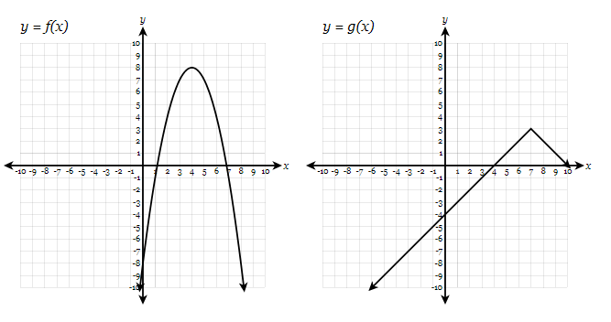

Find the following

f(g(8)) = f(g(4)) = g(f(4)) = f(f(4)) =

Given f(x) = 2x2 + 4x – 8 and g(x) = -4x + 9 find the following

f(g(8)) = f(g(4)) = g(f(4)) = f(f(4)) =

Now find

f(g(x)) g(f(x))

A rock is thrown in a pond, and the radius of the ripple circles increase at a rate of **.5** inch per second. Find an algebraic expression for the area of the ripple in terms of time t, and find the area after **20** seconds.

Amelia is walking away from a 20 feet high street lamp at a rate of **4** ft/sec.  If Amelia is **5’6″** tall, how long will she have walked (both in terms of time and distance) when her shadow is **7** feet long?

Given $f\left(x\right)=\sqrt{2x-8}$ and *g*(x) = x2 + 5. Find f(g(x)) and domain of composite

Decomposition

Let’s say, we have: f(x) = x + 3; g(x) = x2 – 4 ; h(x) = 2x; and k(x) – 5x + 8

Find f(g(h(k(x)))) =

Look back, let’s say we were given $l\left(x\right)=\left({\left(10x+16\right)}^{2}\right)-4)+3$, can you de-compose it into 4 simple functions?

Now you do. Decompose $l\left(x\right)=\left(({5\left(2x+3)+8\right)}^{2}\right)-4$

**Target 3 Assessment**

Find the point on the circle with equation x2 + 6x + y2 – 4y – 7 = 0 which is closest to the point P(1, - 5) . Hint: sketch a graph first

Let’s say you found two coupons for your favorite clothing store: one that is a**____% discount**, and another one that is **$____ off**. The store allows you to use both of them, **in any order**. You need to figure out which way is the better deal. Show algebra and compare the graphs of the two composite functions

Given f(x) = 3x2 + 6x – 10 and g(x) = -2x – 7 find the following

f(g(8)) = f(g(4)) = g(f(4)) = f(f(4)) =

f(g(x)) g(f(x))

Decompose function $l\left(x\right)=\frac{4}{3-\sqrt{4+x^{2}}}$ into as many functions as you can (max is 5 functions)

A small stone is thrown into still water and create a circular wave. The radius r of the water wave increases at the rate of 2 cm per second.   
a) Find an expression for the radius r in terms of time t (in seconds) after the stone was thrown.   
b) If A is the area of the water wave, what is the meaning of the composition A(r(t))   
c) Find the area A of the water wave after 60 seconds.